

CUSTOMER CARE REGISTRY

**PROBLEM-SOLUTION FIT**

TEAM DETAILS:



**Team Name : PNT2022TMID6076**

**College Name :** University Engineering College

**Department :** Computer Science & Engineering

PROBLEM MEMBERS :

* T.ABARNA
* V.MENAGA
* S.ANITHA
* S.SUJI

Problem-Solution Fit 2

PROJECT DESIGN PHASE –I

PROPOSED SOLUTION

|  |  |
| --- | --- |
| **DATE** | **03 NOV 2022** |
| **TEAM ID** | PNT2022TMID46076 |
| **PROJECT NAME** | CUSTOMER CARE REGISTRY |
| **MAXIMUM MARKS** | 5Marks |

Problem-Solution Fit 3

PROJECT DESIGN PHASE –I (PROBLEM-SOLUTION FIT)

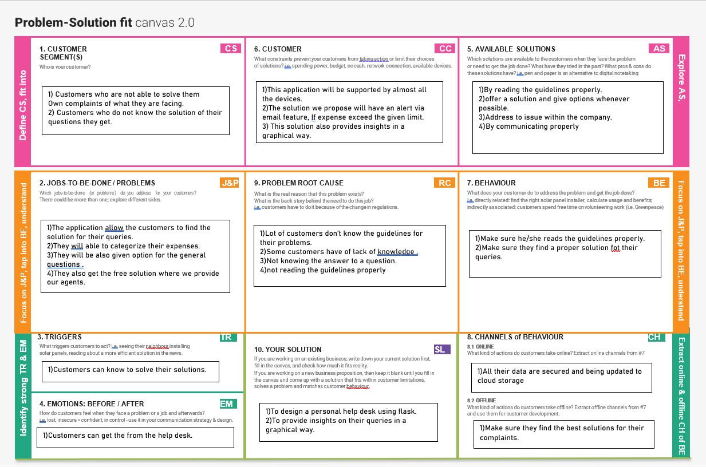

Problem-Solution Fit 4



**Thank you**